**Step-1:-**

**Click on Sing Documnet**

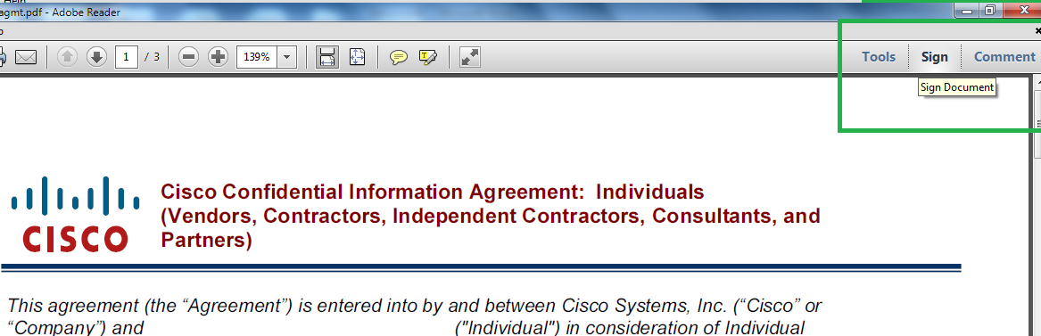

**Step-2:-**

**Select Add or Edit Text Option**

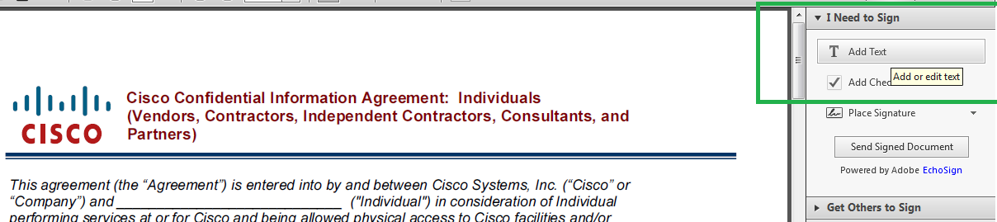

**Step-3:-**

**Type your name as appeared in the sheet/Please check in Cisco Directory how your name appearing**

[**http://wwwin-tools.cisco.com/dir/**](http://wwwin-tools.cisco.com/dir/)

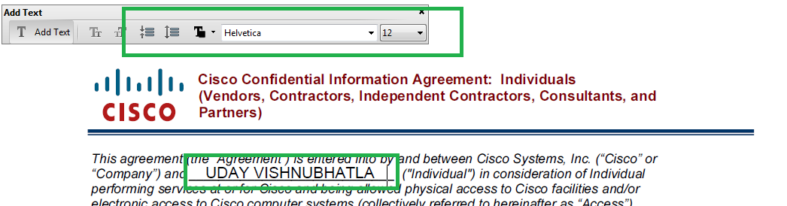

**Step-4:-**

**Please select Place Signature option**

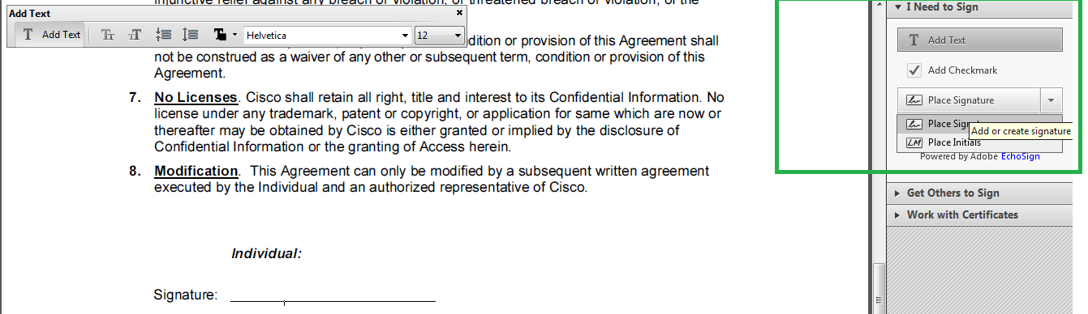

**Step-5:-**

**You can choose the below options for Signing**

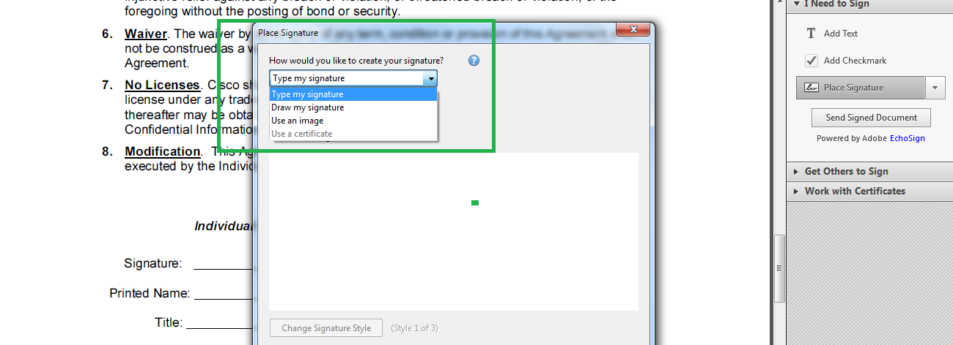

**Step-6:-**

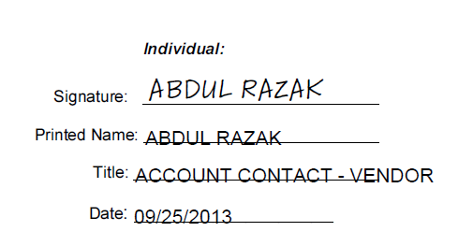

**Step-7:-**

**The naming convention of the Digital copy files should be Lastname_Firstname_Confidentiality_Agreementt.pdf.**

**(Example: Vishnubhatla_ Uday_Confidentiality_agreement.pdf)**

